INDONESIA: Advancing Indonesia’s Lighting Market to High Efficient Technologies (ADLIGHT)
Responses to GEFSec Comments 15 July 2019

Comments & Responses | Reference
- Part I/Table D: Name of the Agency in the 2nd line should be UNEP (not UNDP). Please revise.

Response:  This has now been revised | GEF Portal
- Please address German Council member's comments on the PFD titling "Leapfrogging markets to high efficiency products (appliances, including lighting, and electrical equipment)" which are relevant to all child projects:

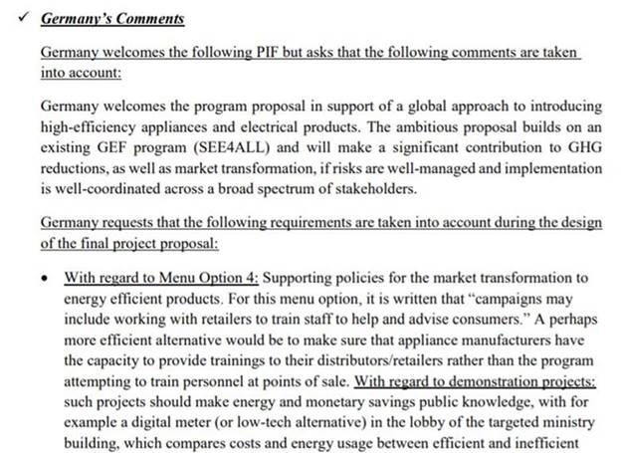
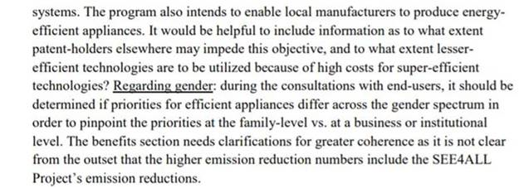

“Germany welcomes the program proposal in support of a global approach to introducing high-efficiency appliances and electrical products. The ambitious proposal builds on an existing GEF program (SEEforALL) and will make a significant contribution to GHG reductions, as well as market transformation, if risks are well-managed and implementation is well-coordinated across a broad spectrum of stakeholders. Germany requests that the following requirements are taken into account during the design of the final project proposal:”

Response: All comments will be taken into account during the project development and will be incorporated into the final project proposal.

“With regard to Menu Option 4: Supporting policies for the market transformation to energy efficient products. For this menu option, it is written that “campaigns may include working with retailers to train staff to help and advise consumers.” A perhaps more efficient alternative would be to make sure that appliance manufacturers have the capacity to provide trainings to their distributors/retailers rather than the program attempting to train personnel at points of sale.”

Response: Thanks for this good suggestion. This is a better approach offering longer-term sustainability and the project can use best practices from the manufacturing partners to the project (OSRAM, Philips, BSH, Mabe, etc). This suggestion will be integrated into project design.

“With regard to demonstration projects: such projects should make energy and monetary savings public knowledge, with for example a digital meter (or low-tech alternative) in the lobby of the targeted ministry building, which compares costs and energy usage between efficient and inefficient systems. The program also intends to enable local manufacturers to produce energy-efficient appliances. It would be helpful to include information as to what extent patent-holders elsewhere may impede this objective, and to what extent lesser-efficient technologies are to be utilized because of high costs for super-efficient technologies?”

Response: We have not yet encountered patent issues blocking the way for energy efficient products, contrarily it is often more expensive material or design that makes the product more expensive. For example, using more efficient material (such as copper) and/or using more insulation in refrigerators. Patent issues and clear measures to transparently and effectively present energy and financial savings will be fully integrated during project development. In regards to the lower efficient technologies being used instead of higher cost super-efficient technologies: the project will support countries to make the transition based on their national circumstances. For example, minimum energy performance standards (MEPS) could be put in place to remove the lower performing products (for example inefficient incandescent lamps) from the market to shift to higher efficient (for example CFLs), and also promoting awareness/demand for highly efficient products (for example LEDs) through demonstration or distribution campaigns of highly efficient products.

“Regarding gender: during the consultations with end-users, it should be determined if priorities for efficient appliances differ across the gender spectrum in order to pinpoint the priorities at the family-level vs. at a business or institutional level.”

Response: Thanks for this good suggestion. This will be integrated into project design.

- According to the GEF's Guidelines on the Project and Program Cycle Policy (paragraphs 7 to 9 pages 37 and 38), the GEF Fee Policy explicitly precludes the merging or crossing over the implementing functions of the GEF Agencies and the execution functions undertaken by a project executing entities (EAs). If there is an in ‘exceptional situations” where there are no other viable options for the execution of the project. the conditions for this exception to be considered by the GEF secretariat. The GEF SEC checked the Project Document (including the paragraph below) whether the Agency is undertaking additional execution function in the project, and we would like to flag whether those execution driven services mentioned are covered by an agreement with the government and if the government has provided a letter to UNDP requesting direct execution for such services. We have not seen such request in the submitted documentation. Please address this issue.

UNDP Direct Project Services as Requested by Government

The UNDP, as GEF Agency for this project, will provide project management cycle services for the project as defined by the GEF Council. In addition, the Government of Indonesia may request UNDP direct services for specific projects, according to its policies and convenience. The UNDP and Government of Indonesia acknowledge and agree that those services are not mandatory, and will be provided only upon Government request. If requested, the services would follow the UNDP policies on the recovery of direct costs. These services (and their costs) are specified in the Letter of Agreement (Annex J). As is determined by the GEF Council requirements, these service costs will be assigned as Project Management Cost, duly identified in the project budget as Direct Project Costs. Eligible Direct Project Costs should not be charged as a flat percentage. They should be calculated on the basis of estimated actual or transaction-based costs and should be charged to the direct project costs account codes: “64397- Services to projects – CO staff” and “74596 – Services to projects – GOE for CO”.

Response: While the Implementing Partner had initially requested UNDP support for recruitment and procurement due to lack of in-house capacity, both the Implementing Partner and the OFP cannot issue request letters as the OFP stated that there is no related GEF policy that the OFP is aware of. On the basis of further communication with the Implementing Partner, it has been decided that the Implementing Partner will provide the tasks as first foreseen to be supported by UNDP (recruitment and procurement related), this has been adjusted accordingly in the Project Budget Table. | ProDoc: Project Budget Table

